III-Development Environment

A-Choice of software development platform

The platform we will choose to work on will be a mobile app. Indeed, our project is based on fast services for daily use, so it needs to be usable at any time to be very convenient for the user. As we all carry our smartphone with us at any time of the day, a mobile app is the most appropriate platform for our service to provide fast and easy-to-use services. Plus, this app needs to be cross-platform. Since our service is based on a collaboration between professionals (restaurant owners, supermarket managers…) and individuals, the more users there are, the more diversity there will be and therefore the more attractive our service will be. We will focus on Android and iOS operating systems because the leading smartphones’ companies in South Korea are Samsung (Android), LG (Android) and iPhone (iOS), according to this Statista’s analysis. But for now, as our programming skills and experience in software engineering are at a development stage, we will only focus on one of the OS previously mentioned, which is Android.

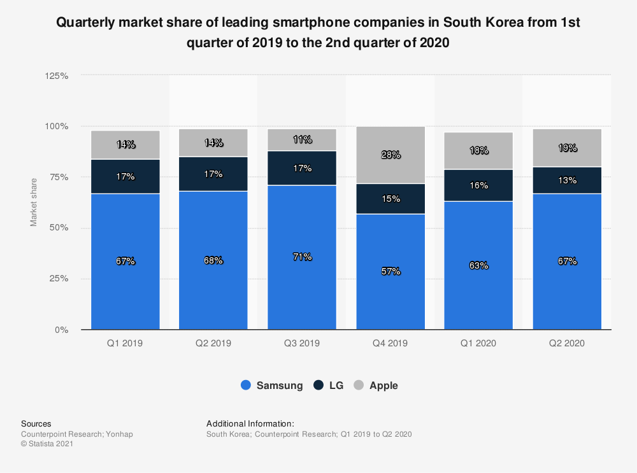

Source : Statista

Concerning the programming language, we will use C#, and more particularly the open-source platform Xamarin. We want to work with C# because all the team members have knowledge and experience on coding with this language. In addition, C# is a very convenient language when it comes to develop mobile applications because it is object oriented, so error detection is simpler, and it has a large community (it is ranked on top 10 most used programming languages among developers), which means that finding support or answers for questions is not as hard as it might be with a lesser language. Finally, this large community also ensure the continued existence and use of the language.

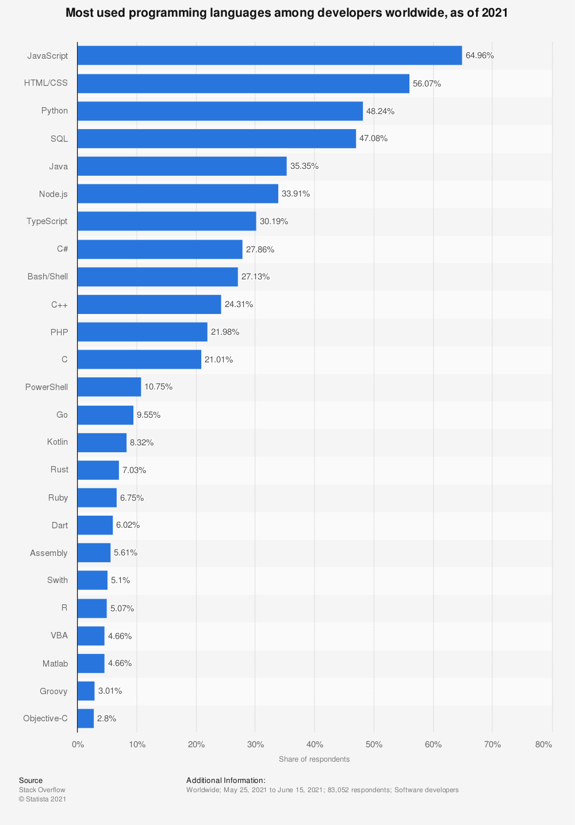

Source : Statista

Regarding Xamarin platform, it will allow us to reach a lot of our prerequisites. Xamarin will make us able to develop a cross-platform app because it contains reusable code, 90% of which can be recycled for the development of apps on various platforms. Xamarin applications can be written on PC or Mac and compile into native application packages, such as an **.apk** file on Android, or an **.ipa** file on iOS. The platform IDE enables such C# coding that the result is a native look and feel of the mobile app. As Xamarin is built on top of .NET, it also automatically handles tasks such as memory allocation, garbage collection and interoperability with underlying platforms.

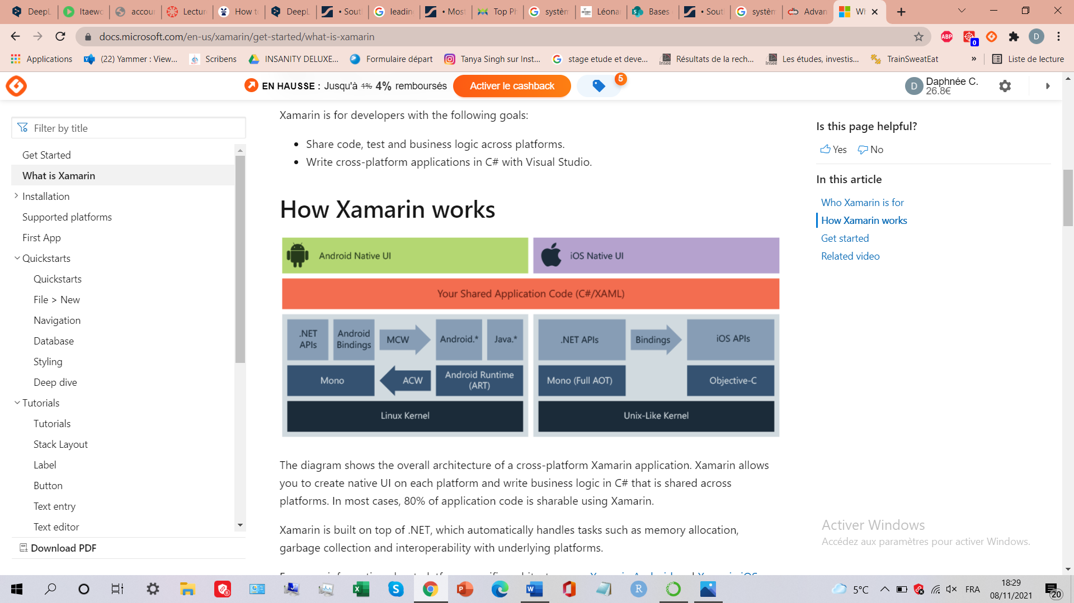

Explanation on how cross platform development works with Xamarin

All of this will allow us to save time, be more efficient and offer a comfortable user experience. Since we plan to use Xamarin, we will also need to use Visual Studio as a code editor.

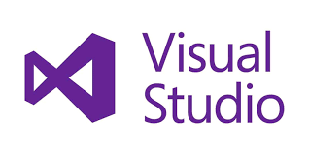

Microsoft Visual Studio :

Microsoft Visual Studio is an [integrated development environment](https://en.wikipedia.org/wiki/Integrated_development_environment) (IDE) from [Microsoft](https://en.wikipedia.org/wiki/Microsoft). It is used to develop [computer programs](https://en.wikipedia.org/wiki/Computer_program), as well as [websites](https://en.wikipedia.org/wiki/Web_site), [web apps](https://en.wikipedia.org/wiki/Web_app), [web services](https://en.wikipedia.org/wiki/Web_service) and [mobile apps](https://en.wikipedia.org/wiki/Mobile_app). Visual Studio uses Microsoft software development platforms such as [Windows API](https://en.wikipedia.org/wiki/Windows_API), [Windows Forms](https://en.wikipedia.org/wiki/Windows_Forms), [Windows Presentation Foundation](https://en.wikipedia.org/wiki/Windows_Presentation_Foundation), [Windows Store](https://en.wikipedia.org/wiki/Windows_Store) and [Microsoft Silverlight](https://en.wikipedia.org/wiki/Microsoft_Silverlight). The most basic edition of Visual Studio, the Community edition, is available free of charge. This is the edition we will use for the development of our project.

As our application will require login, registration features, and a place to save data, we will need a back-end server. AWS (Amazon Web Services) can be used for both android and iOS operating systems, so we will use this one as our back-end server.

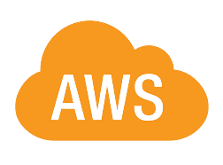

AWS (Amazon Web Service) :

[Amazon web service](https://www.simplilearn.com/tutorials/aws-tutorial/aws-fundamentals) is an online platform that provides scalable and cost-effective cloud computing solutions. AWS is a broadly adopted cloud platform that offers several on-demand operations like compute power, database storage, content delivery, etc. A feature that separates AWS from other cloud services is its capability to launch and scale mobile, e-commerce, and SaaS applications. API-driven code on AWS can enable developers to build uncompromisingly scalable applications without requiring any OS and other systems.

However, as we will have to manage customers data, transactions, and product catalog, we will also need a database to organize and store the data. Since AWS provides another service called Amazon Relational Database Service (RDS), which allow access to a database engine, we will use this service and choose MySQL as a database. Indeed, AWS supports MySQL as a fully managed database service with RDS, which is available for trial at no cost with the AWS Free Tier for one year.

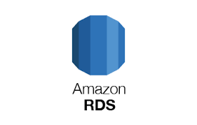

Amazon RDS :

Amazon Relational Database Service (or Amazon RDS) is a distributed [relational database](https://en.wikipedia.org/wiki/Relational_database) service by [Amazon Web Services](https://en.wikipedia.org/wiki/Amazon_Web_Services) (AWS). It is a [web service](https://en.wikipedia.org/wiki/Web_service) running ["in the cloud"](https://en.wikipedia.org/wiki/Cloud_computing) designed to simplify the setup, operation, and [scaling](https://en.wikipedia.org/wiki/Scalability) of a relational database for use in applications. Administration processes like patching the database software, backing up databases and enabling [point-in-time recovery](https://en.wikipedia.org/wiki/Point-in-time_recovery) are managed automatically. Scaling storage and compute resources can be performed by a single [API](https://en.wikipedia.org/wiki/API) call to the AWS control plane on-demand.

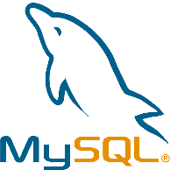

MySQL :

Concerning MySQL, it is one of the most widely adopted free and [open source](https://aws.amazon.com/products/databases/open-source-databases/) relational database and serves as the primary relational data store for many popular websites, applications, and commercial products. With more than 20 years of community-backed development and support, MySQL is a reliable, stable, and secure SQL-based database management system. To work with it, we will use SQL (Structured Query Language).

Cost estimation for the built:



Why the Microsoft Surface Pro 7:

This laptop is powered by the Intel Core i5-1035G4, which is a 10th Gen processor, and an integrated GPU. There are more powerful GPUs in the market but as we are not developing a video game it doesn’t really matter and it should be more than enough. This machine offers 8GB RAM and 128GB SSD-based storage, so compiling android development files and programs will take less time [compared to a laptop with HDD-based storage](https://laptop251.com/ssd-vs-hdd/). 8GB RAM is good enough to read data fast. Like most of the laptops made by Microsoft, this one does not support storage or memory expansion, but the development of our mobile application will not need us to have extra storage. It is also provided with Windows 10 OS, which makes things easier when it comes to using Visual Studio. This is a lightweight laptop that comes with a detachable keyboard and trackpad, it is just 1.1 pounds of weight. Though it is a full-fledged laptop, it is as light as a tablet. It means that we can easily develop new apps from coffee shops or other establishments and the laptop can be carried in a pouch. Lastly, the laptop offers a battery life of up to 10.5 hours on a single charge with support for fast charging, which is very convenient as we are used to meet in cafes for team meetings.

Why the Samsung Galaxy S21 & iPhone 12 Pro:

To make our choice, we just searched for the most frequently bought smartphones in Korea using Android and iOS operating systems. As we plan to make our app available under this two OS, it is important that we can test how our app runs under two different operating systems to make sure that the app can be successfully downloaded, executed, and that it can interact with the supporting back-end content infrastructure.